“Fear not, for I am with you; be not dismayed, for I am your God; I will strengthen you, I will help you, I will uphold you” Isaiah 41:10 |  | 2 Dec 2021
We hope you had a lovely Thanksgiving. We want you to know that we are thankful for you. For your faithfulness in upholding us in prayer. For your financial partnership. For your words of encouragement. And all the other things you do, large and small. God has used you to bless us! We are grateful for you.  We have a significant prayer request to share. We mentioned it in our last newsletter and we are still trying to find the words to describe our need. But we need your help whether we can put words to it or not.  Just before Steve stepped into his new role our family came under spiritual attack. It was subtle at first, but the intensity has increased steadily over the last few months. Bouts of intense anxiety, fear, perfectionism, inadequacy, distraction, pride, regrets, guilt, and uncertainty are plaguing our family. There are days when the chaos in our minds feels almost paralyzing. There are days when sleep is difficult, but tears come easy and often. There are days when communication is disrupted or confused. Our enemy wants to isolate us from each other and hold us hostage with accusations and lies. We are continually praying, “Lord have mercy.”  We know God is with us; that He will strengthen us and uphold us. We know that He who is in us is stronger than he who is in the world. We know that what Satan intends for evil, God always turns to good for his children. And we also know that our Heavenly Father hears the earnest prayers of the saints. That's where you come in. Will you join us in this battle through prayer, and possibly fasting?  We are looking forward to celebrating the birth of our Lord. We plan to keep it simple this year. We wish you and your families the happiest of times together this Christmas. May the Lord bless you in the new year.  Together for the Gospel,  Steve & Glenda Moitozo |  | Please DO NOT post on the internet, but feel free to forward to your church prayer groups, etc.  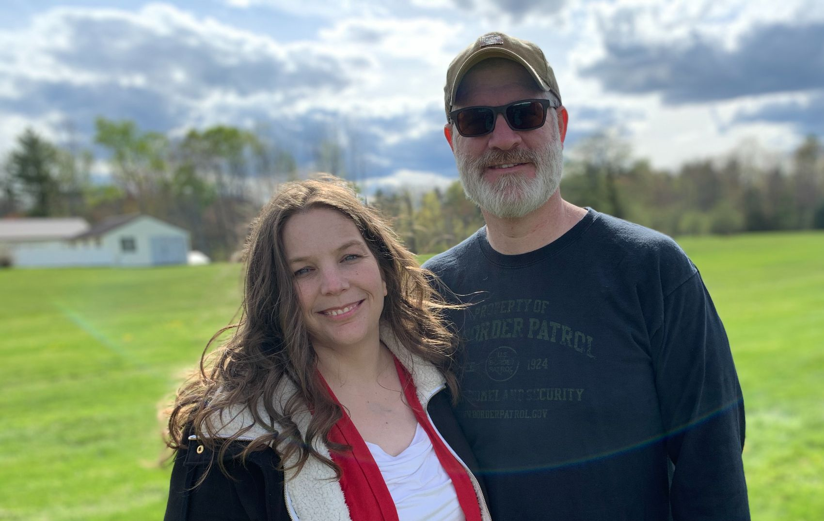  Current income level: 99%  Click to make a quick donation
Contact Us  Steve and Glenda Moitozo  PO Box 1142  Lewiston, ME 04243  207-783-1570  facebook.com/SteveAndGlenda  steven@moitozo.com  glenda@moitozo.com | 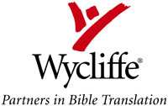 | Contact Wycliffe  (for donations toward our budget)  Our account # 215202  Wycliffe Bible Translators  PO Box 628200, Orlando, FL  32862-8200  1-800-WYCLIFFE  www.wycliffe.org
Checks should be made payable to “Wycliffe Bible Translators” with a separate note indicating
your preference for the ministry of Steve and Glenda Moitozo, Acct # 215202.
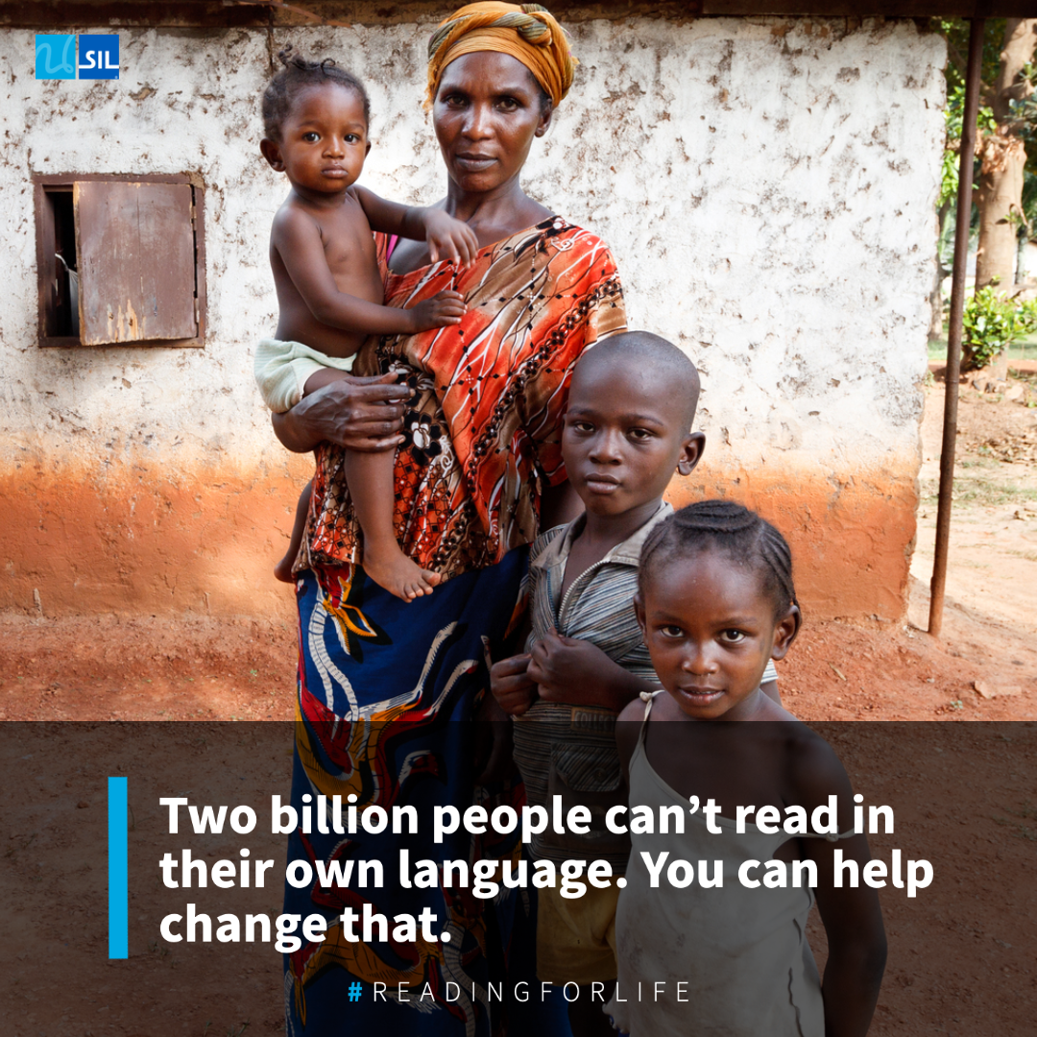
Steve's team is running a Winter fundraising campaign to help people learn to read their languages.

What does reading mean to Agatte, who speaks Ifé, and works as a seamstress in Togo? Before she could read, she often mixed up customers’ orders and lost track of who owed her money. When a literacy class opened up in her village, Agatte signed up right away. With her newfound skills, she can now mark clients’ names on their clothing and keep track of who still needs to pay her. Her business is doing much better and providing support for her family.

Together, we can help make a difference. You can make your tax-deductible gift at https://givedirect.org/sil/reading-for-life/

